National Self-Defense Solutions
Order Form
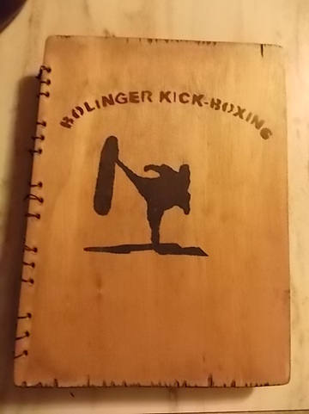
Item# | Description | Cost

Shipping | $2.50
Tax: 7%
Total
Name: _____________________________________
Address: _________________________________________State: ______ Zip: _________________
Phone: _________________________________ Email: _______________________________________

Name on Credit Card: _________________________________
Credit Card Number: _________________________________ Exp. Date: _______________________
3 digit number on back of Credit Card: _________

If paying by Check or Money order: Pay to the order of “National Self-defense Solutions”, 507 Niobrara Avenue, Alliance, NE 69301.

